Vikingland CSP/ Douglas County Socialization Activity
Wed., Sept. 2nd, @2pm: Drop-In Center Advisory Council.
“Diamond Painting” every Thurs. @2pm: Come join your peers and try Diamond Painting!
Fri., Sept. 4th, @1pm: Coffee Talk w/Carmen. Topic, “Reset & Recharge: Building Healthy Routines for Fall”
Fri., Sept. 4th, @2pm: Pool, Cash for prizes! No cost for you!
Sat., Sept. 5th, @1pm: Apples to Apples
Tues., Sept. 8th, @2pm: Switch Bowling. Cash for prizes! No cost for you!
Fri., Sept. 11th, @2pm: BINGO! Cash for prizes! No cost for you!

Sat., Sept. 12th, @1pm: Fact or Crap at the center.

Wed., Sept. 16th, 1pm: Come join the Monthly Birthday Celebration. Everyone is welcome.

Wed., Sept. 16th, @2pm: Kat’s Kraft’s at the Center.

Fri., Sept. 18th, @12pm: Brophy bonfire, food, and games. Come hungry, come ready to play, and come prepared to make some s’more memories! We’ll have hot dogs, chips, water, s’mores, games, and a bonfire—basically everything you need for an afternoon of fun (except your competitive spirit… bring that yourself! 😂).
You MUST sign up to attend!
So grab your friends, get signed up, bring your game face, and let’s get this fire started!

Mon., Sept. 21st, @2pm: BINGO! Cash for prizes! No cost for you!

Tues., Sept. 22nd, @12pm-1pm: NAMI Peer Connection Group. Bring a sack lunch.

Wed., Sept. 23rd, @2pm: Name That Tune.
Fri., Sept. 25th, @11am-1pm: NAMI walk at Noonan’s Park.
Sat., Sept. 26th, @1pm: BINGO! Cash for prizes! No cost for you!
Tues., Sept. 29th, @2pm: Lego’s with Bill. Come join Bill as he illustrates ways to build Lego’s. We have a few small kits for you to build and keep. (one per person)
Tues., Sept. 29th, @5pm: NAMI meeting at the Drop-in center.
Let's Go Fishing Pontoon Ride– September 2026 Opportunities: Enjoy the beauty of our local lakes this summer with our Let's Go Fishing outing! We have a pontoon ride scheduled for September. Space is limited, so be sure to sign up before the deadline (September14, 2026): Friday, September 18, 2026 12:15 pm-2:15 pm. Le Homme Dieu East Boat Ramp (Krueger Creek) If you have any questions or would like to sign up, please talk with your ARMHS worker or a staff member.

  - 09-05 Jennifer Z. 09-10 Victoria V. 09-14 Kayla S. 09-19 Deanna R. 09-26 Melissa S.
Future Activities to Put on Your Calendar:  Let's Go Fishing Pontoon Ride– September 2026 Opportunities: Enjoy the beauty of our local lakes this summer with our Let's Go Fishing outing! We have a pontoon ride scheduled for September. Space is limited, so be sure to sign up before the deadline (September14, 2026): Friday, September 18, 2026 12:15 pm-2:15 pm. Le Homme Dieu East Boat Ramp (Krueger Creek) If you have any questions or would like to sign up, please talk with your ARMHS worker or a staff member.
Diamond Painting: Held every Thursday at 2pm in the Drop-In-Center. Many have joined us and it has been fun to relax and discover how fun Diamond painting can be! Supplies are provided, so come try it!
Check out our website @ www.vikinglandcsp.com
Come join us for a free cup of coffee during our Drop-In Center hours (1 pm – 5 pm Mon. – Fri & 12 pm – 4pm Sat.)
Local Advisory Council at DCSS meeting is Thursday October 15th, 2026, at 2:30 pm.
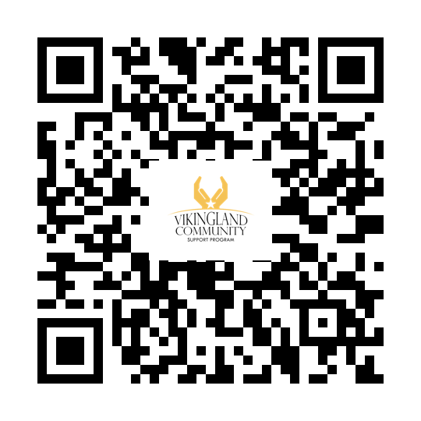Facebook Website 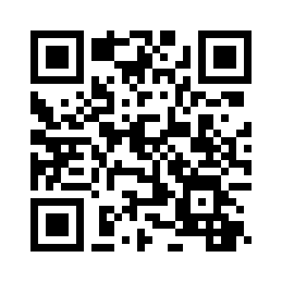

THE HEN’S NEST
BY GALE PETERSON

Lessen pain in hands or writs by placing them in a sink of warm H2O!
This therapy eases the discomfort, making it easier to get on with life and work.
Use hottest water you can handle.

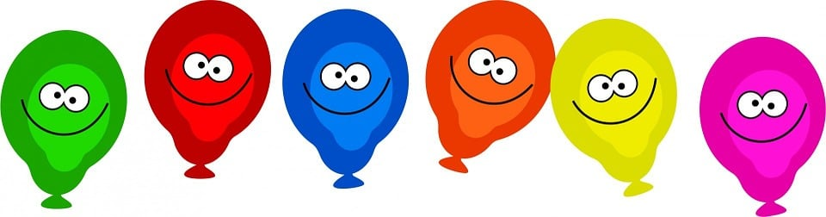
Check out the Monthly Birthday celebration. Come help celebrate on 09/16/26 1pm at the Drop-in Center.

Grape Stomp Festival: at Carlos Creek Winery on September 18–20, 2026.
Saturday Story Hour: Hosted weekly on Saturdays at 10:00 AM at Cherry Street Books through December.

Alexandria Farmers Market in 2026 operates at Big Ole Central Park (corner of 2nd Ave & Broadway in downtown Alexandria).
Tue: 9 am- 12 pm, Thurs: 3 pm – 6 pm, Sat: 9 am – 12 pm
EVERY DAY IS MENTAL HEALTH DAY!
2026
CONVERSATIONS: Region 4 South Adult Mental Health hosts an advisory committee meeting where stakeholders made up of providers, consumers, and family members gather to discuss and improve the local mental health service needs. The purpose of the CONVERSATIONS initiative is to implement systemic change in the delivery of community-based mental health services for adults who have a serious and persistent mental illness. Region 4 South AMHC welcomes individuals to our CONVERSATIONS meetings; for more information, please call Christine Bradley at (320) 815-7284 or email: christine.bradley@r4south.org
*Meetings are typically the 2nd Tuesday at 9:30 am in Hoffman, MN. No Meetings in: February, April, July, and October

