Vikingland CSP/ Douglas County Socialization Activity
Wed., June 3rd, @2pm: Drop-In Center Advisory Council.
“Diamond Painting” every Thurs. @2pm: Come join your peers and try Diamond Painting! NO group on May 21st.
Fri., June 5th, @2pm: Pool, Cash for prizes! No cost for you!
Tues., June 9th, @2pm: Switch Bowling. Cash for prizes! No cost for you!

Fri., June 12th, @12pm: Join us for a fun Picnic at Brophy Wayside Park, located at 4172 County Hwy 82, Alexandria, MN 56308, on Friday at 12:00 PM! Enjoy a relaxing afternoon with friends, fresh air, and delicious food including sandwiches, chips, s’mores, and a drink. Please sign up in the Drop-In Center by Wednesday, 6/10/26, so we can plan accordingly. We hope to see you there!

Fri., June 12th, @2pm: BINGO! Cash for prizes! No cost for you!

Sat., June 13th, @1pm: Fact or Crap at the center.

Mon., June 15th, @2pm: BINGO! Cash for prizes! No cost for you!

Wed., June 17th, 22pm: Come join the Monthly Birthday Celebration. Everyone is welcome.

Wed., June 17th, @2pm: Kat’s Kraft’s at the Center.

Fri., June 19th, @2pm: Chase the Ace

Tues., June 23rd, @12pm-1pm: NAMI Peer Connection Group. Bring a sack lunch.

Wed., June 24th, @2pm: Name That Tune.
Thurs., June 25th, @3:15pm: Get ready to catch ‘em all at our Pokémon Go Group on Thursday, June 25, 2026, at 3:15 PM at the Drop-In Center! All are welcome to come explore, connect, and enjoy a fun afternoon of Pokémon adventures together. Come join the fun and make new friends along the way!

Fri., June 26th, @1pm: Coffee Talk w/Carmen—topic: “Building Wellness Through Connection”.
Sat., June 27th, @1pm: BINGO! Cash for prizes! No cost for you!
Tues., June 30th, @2pm: Lego’s with Bill. Come join Bill as he illustrates ways to build Lego’s. We have a few small kits for you to build and keep. (one per person)
Tues., June 30th, @5pm: NAMI meeting at the Drop-in center.

  - 06/01 Larry C. & Denise F. 06/03 Lance B. 06/05 Kennedy O. 06/09 Nancy H. 06/17 Brent E. 06/20 Connie C. 06/22 Alexander M. 06/24 Maude S. 06/29 Brenda B. 06/30 Amy V.

THE HEN’S NEST
BY GALE PETERSON

  - “Gratitude Attitude”
  - Showing appreciation is key to strengthening your relationships.
  - A quick letter, a post card, or a simple “Thanks for being there for me.”
  - We all want to see our efforts valued.
  - Being thankful blesses all those involved.

Future Activities to Put on Your Calendar: 
Fri., June 12th, @ 12pm: Join us for a fun Picnic at Brophy Wayside Park, located at 4172 County Hwy 82, Alexandria, MN 56308, on Friday at 12:00 PM! Enjoy a relaxing afternoon with friends, fresh air, and delicious food including sandwiches, chips, s’mores, and a drink. Please sign up in the Drop-In Center by Wednesday, 6/10/26, so we can plan accordingly. We hope to see you there!

Thurs., June 25th, @ 3:15 pm: Get ready to catch ‘em all at our Pokémon Go Group on Thursday, June 25, 2026, at 3:15 PM at the Drop-In Center! All are welcome to come explore, connect, and enjoy a fun afternoon of Pokémon adventures together. Come join the fun and make new friends along the way!

Diamond Painting: Held every Thursday at 2pm in the Drop-In-Center. Many have joined us and it has been fun to relax and discover how fun Diamond painting can be! Supplies are provided, so come try it!
Check out our website @ www.vikinglandcsp.com
Come join us for a free cup of coffee during our Drop-In Center hours (1 pm – 5 pm Mon. – Fri & 12 pm – 4pm Sat.)
Local Advisory Council at DCSS meeting is Thursday June 18th, 2026, at 2:30 pm.

Check out our website @ www.vikinglandcsp.com


Check out the Monthly Birthday celebration. Come help celebrate on 06/17/26 1pm at the Drop-in Center.

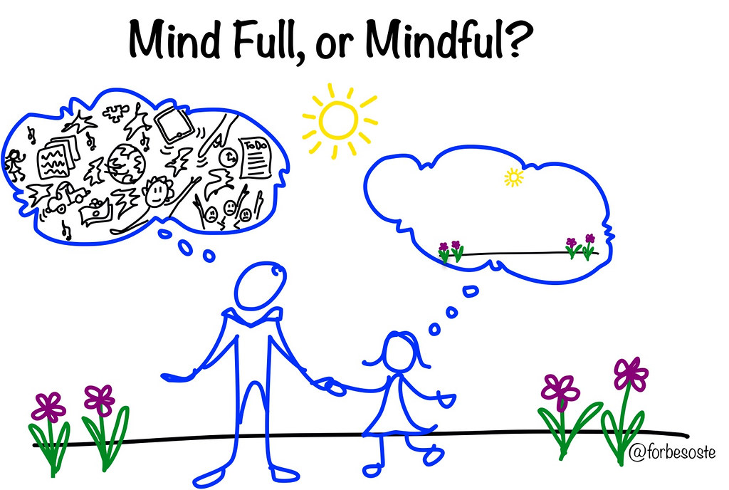

We are guessing that we had over two hundred people in attendance for our Mental Health Awareness Walk.
Stay tuned for the “Paint the Town Green Winner”!
2026
CONVERSATIONS: Region 4 South Adult Mental Health hosts an advisory committee meeting where stakeholders made up of providers, consumers, and family members gather to discuss and improve the local mental health service needs. The purpose of the CONVERSATIONS initiative is to implement systemic change in the delivery of community-based mental health services for adults who have a serious and persistent mental illness. Region 4 South AMHC welcomes individuals to our CONVERSATIONS meetings; for more information, please call Christine Bradley at (320) 815-7284 or email: christine.bradley@r4south.org
*Meetings are typically the 2nd Tuesday at 9:30 am in Hoffman, MN. No Meetings in: February, April, July, and October
EVERY DAY IS MENTAL HEALTH

