Vikingland CSP/ Douglas County Socialization Activity
Wed., July 1st, @2pm: Drop-In Center Advisory Council.
“Diamond Painting” every Thurs. @2pm: Come join your peers and try Diamond Painting!
Fri., July 3rd, @2pm: VCSP office closed
Fri., July 3rd, @2pm: Pool, Cash for prizes! No cost for you!
Fri., July 10th, @2pm: BINGO! Cash for prizes! No cost for you!

Sat., July 11th, @1pm: Fact or Crap at the center.

Tues., July 14th, @2pm: Switch Bowling. Cash for prizes! No cost for you!

Wed., July 15th, 2pm: Come join the Monthly Birthday Celebration. Everyone is welcome.

Wed., July 15th, @2pm: Kat’s Kraft’s at the Center. Round two of Tie Dye, Bring something you would like to tie dye and have some fun.

Mon., July 20th, @2pm: BINGO! Cash for prizes! No cost for you!

Tues., July 21st, @12pm-1pm: NAMI Peer Connection Group. Bring a sack lunch.

Fri., July : Coffee Talk w/Carmen—NO COFFEE TALK.
Sat., July 25th, @1pm: BINGO! Cash for prizes! No cost for you!
Tues., July 28th, @2pm: Lego’s with Bill. Come join Bill as he illustrates ways to build Lego’s. We have a few small kits for you to build and keep. (one per person)
Tues., July 28th, @5pm: NAMI meeting at the Drop-in center.
Wed., July 29th, @2pm: Name That Tune.
Let's Go Fishing – July & August 2026 Opportunities: Enjoy the beauty of our local lakes this summer with our Let's Go Fishing outings! We have several pontoon rides and fishing trips scheduled for July and August. Space is limited, so be sure to sign up before the deadlines: Friday, July 10, 2026 – Pontoon Ride, Friday, July 17, 2026 – Fishing Trip, Friday, July 24, 2026 – Pontoon Ride, Friday, August 7, 2026 – Pontoon Ride, Friday, August 28, 2026 – Fishing Trip. To give everyone an opportunity to enjoy time on the water, we ask that each participant sign up for only one pontoon ride or fishing trip. If you have any questions or would like to register, please talk with your ARMHS worker or a staff member.

  - 07/06 Bobbi S. 07/06 Tim S. 07/14 Val S. 07/18 Brian R. 07/20 Angela O. 07/24 Julie P. 07/26 Mary S. 07/26 Sandy T. 07/31 Elizebeth A.
Future Activities to Put on Your Calendar:  Let's Go Fishing – July & August 2026 Opportunities: Enjoy the beauty of our local lakes this summer with our Let's Go Fishing outings! We have several pontoon rides and fishing trips scheduled for July and August. Space is limited, so be sure to sign up before the deadlines: Friday, July 10, 2026 – Pontoon Ride, Friday, July 17, 2026 – Fishing Trip, Friday, July 24, 2026 – Pontoon Ride, Friday, August 7, 2026 – Pontoon Ride, Friday, August 28, 2026 – Fishing Trip. To give everyone an opportunity to enjoy time on the water, we ask that each participant sign up for only one pontoon ride or fishing trip. If you have any questions or would like to register, please talk with your ARMHS worker or a staff member.
Diamond Painting: Held every Thursday at 2pm in the Drop-In-Center. Many have joined us and it has been fun to relax and discover how fun Diamond painting can be! Supplies are provided, so come try it!
Check out our website @ www.vikinglandcsp.com
Come join us for a free cup of coffee during our Drop-In Center hours (1 pm – 5 pm Mon. – Fri & 12 pm – 4pm Sat.)
Local Advisory Council at DCSS meeting is Thursday August 20th, 2026, at 2:30 pm.
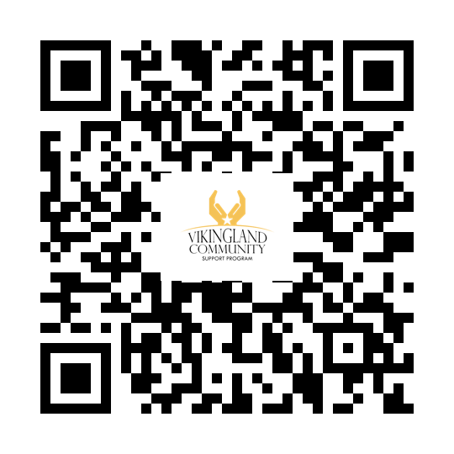Facebook Website 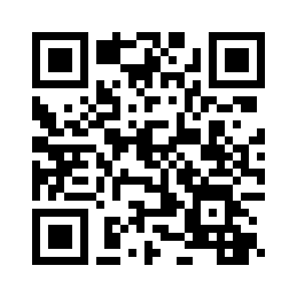

THE HEN’S NEST
BY GALE PETERSON

“USA Birthday”
Now, in July, we are celebrating America’s 250th year of success.
We, in our country can rejoice in the freedoms and blessings we sometimes take for granted.
I served in the regular U.S. Air Force. It’s changed me to appreciate my citizenship more passionately.

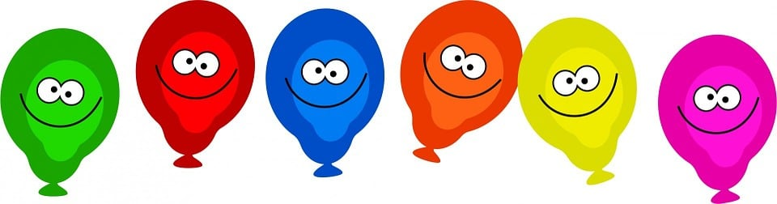
Check out the Monthly Birthday celebration. Come help celebrate on 07/15/26 1pm at the Drop-in Center.

Pride in the Park: Saturday July 11th, 2026 11AM to 4PM at City Park
Waterama 2026: in Glenwood July 22nd, through July 26th, 2026
Art in the Park 2026: July 25th, 9AM to 5PM and July 26th 10AM to 4PM

“Paint the Town Green” Winner was Bobbi Smith at Alexandria City Hall. Thank you to all that participated!
2026
CONVERSATIONS: Region 4 South Adult Mental Health hosts an advisory committee meeting where stakeholders made up of providers, consumers, and family members gather to discuss and improve the local mental health service needs. The purpose of the CONVERSATIONS initiative is to implement systemic change in the delivery of community-based mental health services for adults who have a serious and persistent mental illness. Region 4 South AMHC welcomes individuals to our CONVERSATIONS meetings; for more information, please call Christine Bradley at (320) 815-7284 or email: christine.bradley@r4south.org
*Meetings are typically the 2nd Tuesday at 9:30 am in Hoffman, MN. No Meetings in: February, April, July, and October
EVERY DAY IS MENTAL HEALTH DAY!

