September 9th Conversations
“A meeting of the Stakeholders of the Region 4 South Mental Health Consortium”
September 9th, 2025 9:30–11:00
Hoffman Community Center
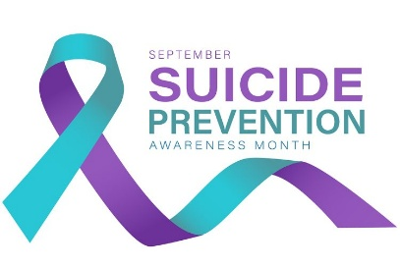

AGENDA
Welcome & Introductions 9:30-9:45
“Name, Role, “What is your favorite fall activity”
Administrator Update 9:45-10:00
Announcements
LAC Updates 10:00-10:15
Drop in Center Updates 10:15-10:25
Senior Life Solutions-Terri Swenson 10:30-11:00
Suicide Awareness

Conversation 2025 Meeting Dates
October- No Meeting Day at Home
November- No Meeting “Grateful Gathering”
December 9th 2025

