**May Conversations**   
***“A meeting of the Stakeholders of the Region 4 South Mental Health Consortium”***   
**May 13th, 2025 9:30–11:00**   
**Hoffman Community Center**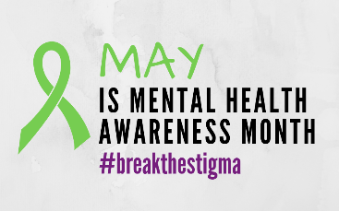

**AGENDA**

Welcome & Introductions 9:30-9:45  
*“Name, Role, “Pick a color that describes your May mood”*

Administrator Update 9:45-10:00  
*Q1 Reporting  
Announcements- ACT; Events*

LAC Updates 10:00-10:15

Drop in Center Updates 10:15-10:25

SPEAKERS 10:25-11:00  
*Heather Cogger- Senior life Solutions with Glacial Ridge  
Brita Smith- peer support specialist presentation*

Conversation 2025 Meeting Dates

**June 10th 2025  
July- No Meeting**

**August 12th 2025**

**September 9th 2025  
October- No Meeting Day at Home**

**November- No Meeting- Grateful Gathering**

**December 9th 2025**